 | American International University- Bangladesh (AIUB)  Faculty of Engineering (FE)
Course Name : |  | Digital Logic & Circuits Laboratory |  |  |  |  | Course Code : |  | EEE 1204
Semester : |  | Fall 2024-25 |  |  |  |  | Sec : |  | G
Lab Instructor : |  | MD. ALOMGIR KABIR |  |  |  |  | Group : |  | 07
Experiment No : |  | 04
Experiment Name : |  | Designing Multiplexer (MUX) and De-multiplexer (DEMUX), Priority Encoder and Decoder Circuits
Submitted by (NAME): |  | Chinmoy Guha |  |  |  | Student ID: |  |  | 22-48056-2
Group Members |  |  |  |  | ID |  |  | Name
 |  |  |  | 1. | 22-48056-2 |  |  | CHINMOY GUHA
 |  |  |  | 2. | 22-48067-2 |  |  | SUVRA CHAKRABORTY
 |  |  |  | 3. | 22-47975-2 |  |  | MOHAMMAD ANSAR UDDIN
 |  |  |  | 4. | 22-49385-3 |  |  | NAZMUL HASSAN NAYEEM
 |  |  |  | 5. | 22-49393-3 |  |  | EFAZ MASHRUR AMIN
 |  |  |  | 6.
 |  |  |  | 7.
Performance Date : |  |  | 13/11/24 |  |  | Due Date : |  |  |  | 20/11/24
Marking Rubrics (to be filled by Lab Instructor)
Category | Proficient  [6] | Good  [4] | Acceptable  [2] | Unacceptable [1] | Secured Marks
Theoretical Background, Methods  & procedures sections | All information, measures and variables are provided and explained. | All Information provided that is sufficient, but more explanation is needed. | Most information correct, but some information may be missing or inaccurate. | Much information missing and/or inaccurate.
Results | All of the criteria are met; results are described clearly and accurately; | Most criteria are met, but there may be some lack of clarity and/or incorrect information. | Experimental results don’t match exactly with the theoretical values and/or analysis is unclear. | Experimental results are missing or incorrect;
Discussion | Demonstrates thorough and sophisticated understanding. Conclusions drawn are appropriate for analyses; | Hypotheses are clearly stated, but some concluding statements not supported by data or data not well integrated. | Some hypotheses missing or misstated; conclusions not supported by data. | Conclusions don’t match hypotheses, not supported by data; no integration of data from different sources.
General formatting | Title page, placement of figures and figure captions, and other formatting issues all correct. | Minor errors in formatting. | Major errors and/or missing information. | Not proper style in text.
Writing & organization | Writing is strong and easy to understand; ideas are fully elaborated and connected; effective transitions between sentences; no typographic, spelling, or grammatical errors. | Writing is clear and easy to understand; ideas are connected; effective transitions between sentences; minor typographic, spelling, or grammatical errors. | Most of the required criteria are met, but some lack of clarity, typographic, spelling, or grammatical errors are present. | Very unclear, many errors.
Comments: |  |  |  | Total Marks  (Out of ):

Abstract:

The main purpose of this experiment is to recognize, design and implement Multiplexer (MUX), De-multiplexer (DEMUX), Encoder and decoder circuits using basic logic gates. These types of circuits are useful in information relaying, conversion, compression and any kind of suppressing confidential or classified information. And as an electrical and electronics engineer, these things are vital to get accustomed to.

Objectives:

- To get introduced with MUX, DEMUX, Encoder and Decoder circuits.

- To design these circuits and implement it with basic logic gates.

- To create truth table results from the circuits.

Theory and Methodology:

Part I: Multiplexer and De-multiplexer

A multiplexer, often called a mux, is a device that channels one input from several options to a single output line. It uses nnn selection lines to choose between 2n2^n2n available inputs. This functionality is why it is sometimes referred to as a data selector.
On the other hand, a de-multiplexer, or de-mux, works in the opposite way. It takes a single input and distributes it to one of several output lines, determined by a selection process.

Multiplexer:
In computer systems, selecting data from multiple sources is often required. For example, consider four data inputs D0, D1, D2, and D3, which vary over time. A circuit can be designed to output one of these inputs based on two selection pins, S1 and S0. The four possible combinations of S1 and S0 — (0,0), (0,1), (1,0), and (1,1) — correspond to D0, D1, D2, and D3, respectively.
A multiplexer with n selection pins can handle 2^n inputs, such as 4-to-1, 8-to-1, or 16-to-1 configurations. In this 4-to-1 design, 2 selection pins control 4 inputs. While a complete truth table for 6 inputs (including pins) has 64 combinations, a simpler method can streamline the process
Table: 1

S1 | S0 | f
0 | 0 | D0
0 | 1 | D1
1 | 0 | D2
1 | 1 | D3

From the above truth table, we can write the function as given below.
𝑓 = S1 S0 D0 + S1 S0 D1 + S1 S0 D2 + S1 S0 D3 (1)
The logic circuit of the equation (1) is given in figure 1.

De-multiplexer:

A de-multiplexer, or de-mux, works as the reverse of a multiplexer. It takes a single input and distributes it to multiple outputs based on one or more selection pins. The input signal is routed to one of the outputs, while all other outputs remain low. De-multiplexers are categorized based on the number of outputs, such as 1-to-2, 1-to-4, or 1-to-8 configurations. If there are \(n\) selection pins, the de-multiplexer can support up to \(2^n\) outputs.

Here, we will design a 1-to-4 de-multiplexer with one input, Din, two selection pins, S1 and S0, and four outputs: D0, D1, D2, and D3. The selection pins determine the output as follows: if S1 = 0 and S0 = 0, then D0 = Din; if S1 = 0 and S0 = 1, then D1 = Din; if S1 = 1 and S0 = 0, then D2 = Din; and if S1 = 1 and S0 = 1, then D3 = Din. A truth table can represent this behavior.

Table: 2

S1 | S0 | D0 | D1 | D2 | D3
0 | 0 | Din | 0 | 0 | 0
0 | 1 | 0 | Din | 0 | 0
1 | 0 | 0 | 0 | Din | 0
1 | 1 | 0 | 0 | 0 | Din

From the above truth table we can write the functions for D0 ,D1, D2 and D3 as given below.

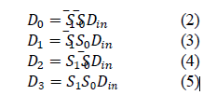

The circuit for 1-to-4-line de-mux is given below.

It is also possible to construct 4-to-1 multiplexer (and 1-to-4 de-multiplexer) using 2-to-1 multiplexers (1- to-2 demultiplexers) only. Figures 3 and 4 show the construction of 4-to-1 multiplexer using 2-to-1 multiplexers and 1-to-4 de-multiplexer using 1-to-2 de-
multiplexers only.

Part II: Encoder and Decoder:
An encoder is a circuit or device that transforms information from one format or code into another, while a decoder performs the opposite function, converting encoded data back into its original form. Both are examples of combinational circuits.
Encoding and decoding are widely used concepts with applications in fields such as electronics, software, medical devices, and telecommunications. In this experiment, a simple 2-to-4-line decoder and a decimal-to-BCD encoder will be designed.
A decoder translates binary data from nnn input lines into a maximum of 2^n unique output lines. For instance, a 2-to-4-line decoder takes two inputs and produces outputs across four lines.

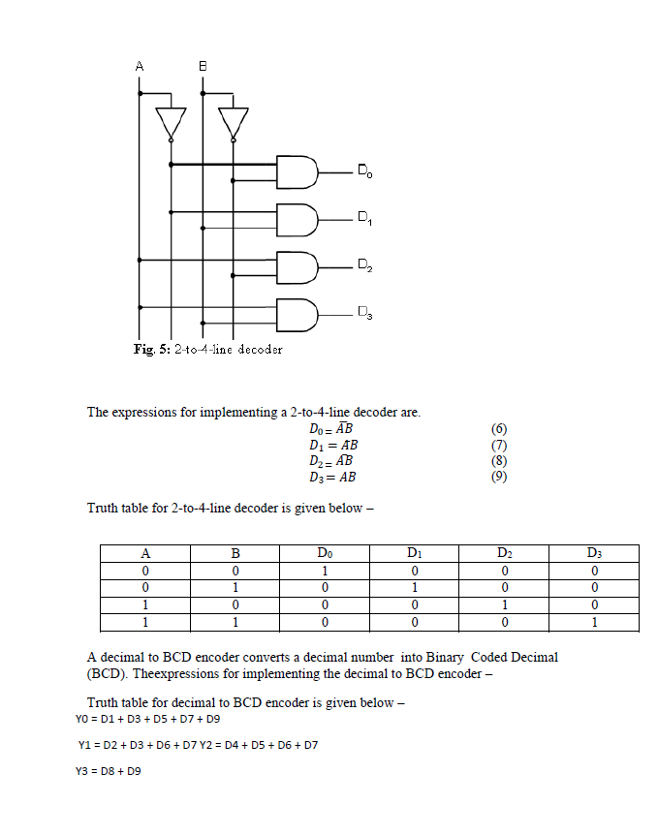
Truth table for decimal to BCD encoder is given below –
 | Dec. | Y3 | Y2 | Y1 | Y0
 | D0 | 0 | 0 | 0 | 0
 | D1 | 0 | 0 | 0 | 1
 | D2 | 0 | 0 | 1 | 0
 | D3 | 0 | 0 | 1 | 1
 | D4 | 0 | 1 | 0 | 0
 | D5 | 0 | 1 | 0 | 1
 | D6 | 0 | 1 | 1 | 0
 | D7 | 0 | 1 | 1 | 1
 | D8 | 1 | 0 | 0 | 0
 | D9 | 1 | 0 | 0 | 1

Priority encoder:
A priority encoder is a circuit or algorithm that reduces multiple binary inputs into a smaller number of outputs. It provides the binary representation of the highest-priority input bit that is active, starting from zero. Priority encoders are commonly used in systems to handle interrupt requests by prioritizing the most significant input. If multiple inputs are active simultaneously, the one with the highest priority is processed.

In this experiment, a 4-to-2 priority encoder with a priority sequence of 2, 1, 3, and 0 is demonstrated. This means input 2 has the highest priority, while input 0 has the lowest. For example, if input 2 is active, all other inputs are ignored, and the output is the binary representation of 2, which is Y1Y0 = 10. If input 2 is inactive, priority moves to input 1. If input 1 is active, inputs 3 and 0 are ignored, and the output becomes Y1Y0 = 01, and so on.

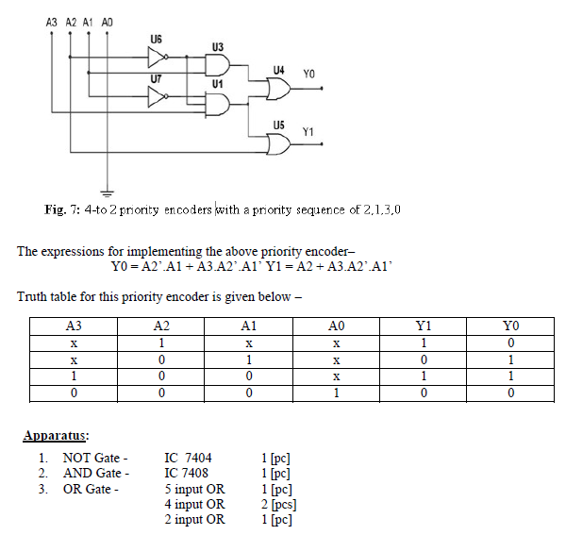

Experimental Procedure with Data & Simulations:
First a multiplexer was designed, implemented, and simulated. The simulation is shown in figure 6 and the truth table is given in table 1.

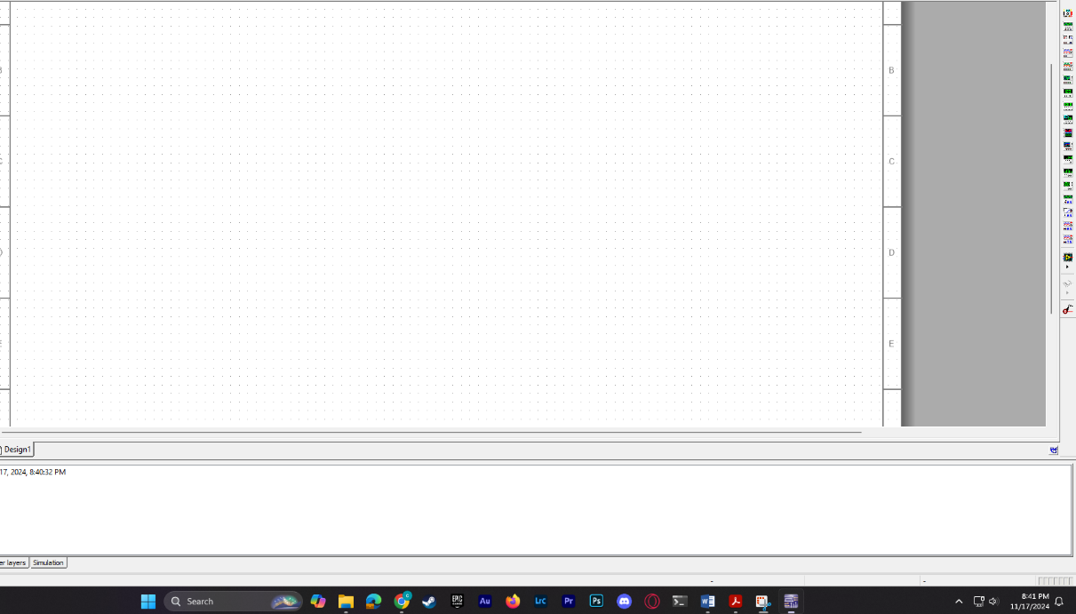

Figure 6: Simulated MUX.

Table 01: Truth table for MUX

S1 | S0 | f
0 | 0 | D0
0 | 1 | D1
1 | 0 | D2
1 | 1 | D3

Secondly, a demultiplexer was designed, implemented, and simulated.

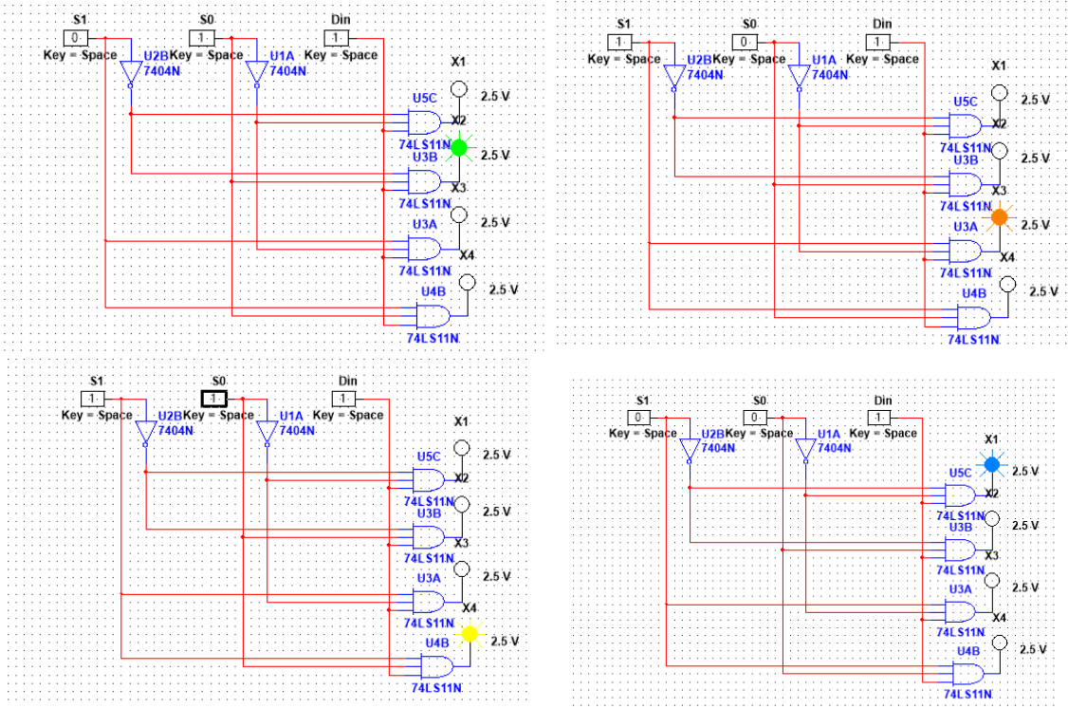









Figure 7: Simulated DEMUX

Table 02: Truth table for DEMUX

S1 | S0 | D0 | D1 | D2 | D3
0 | 0 | Din | 0 | 0 | 0
0 | 1 | 0 | Din | 0 | 0
1 | 0 | 0 | 0 | Din | 0
1 | 1 | 0 | 0 | 0 | Din

Afterwards a 2-to-4-line decoder was implemented and simulated.

Table 3: Truth table for decoder.

A | B | D0 | D1 | D2 | D3
0 | 0 | 1 | 0 | 0 | 0
0 | 1 | 0 | 1 | 0 | 0
1 | 0 | 0 | 0 | 1 | 0
1 | 1 | 0 | 0 | 0 | 1

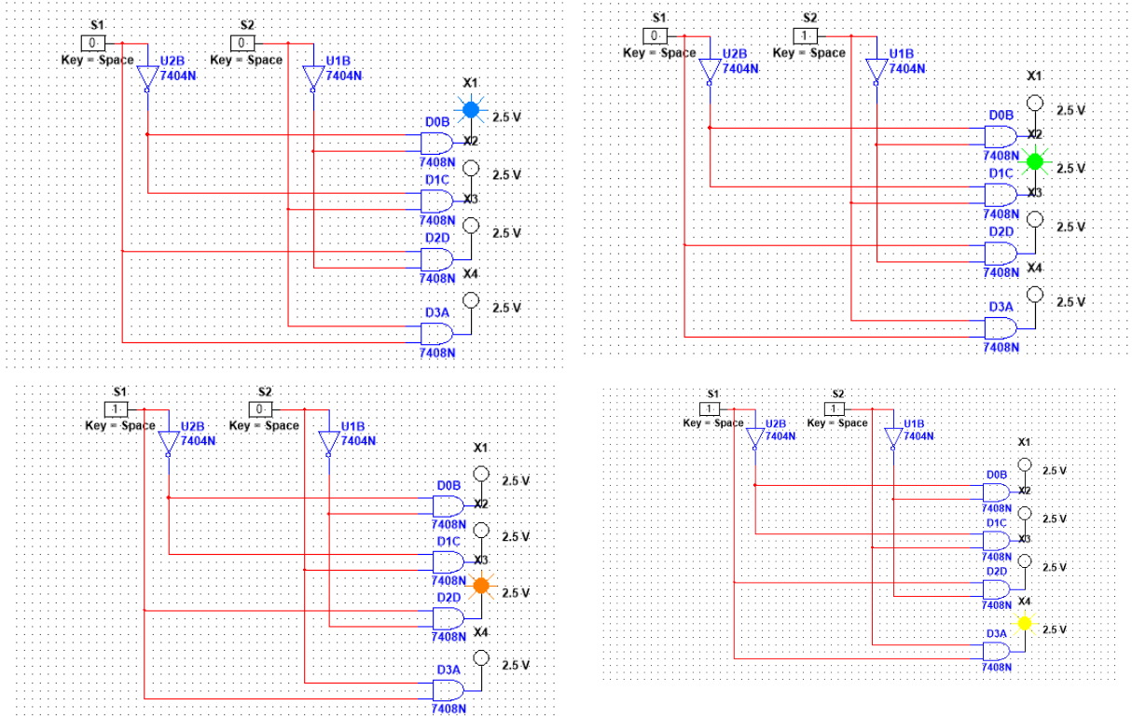
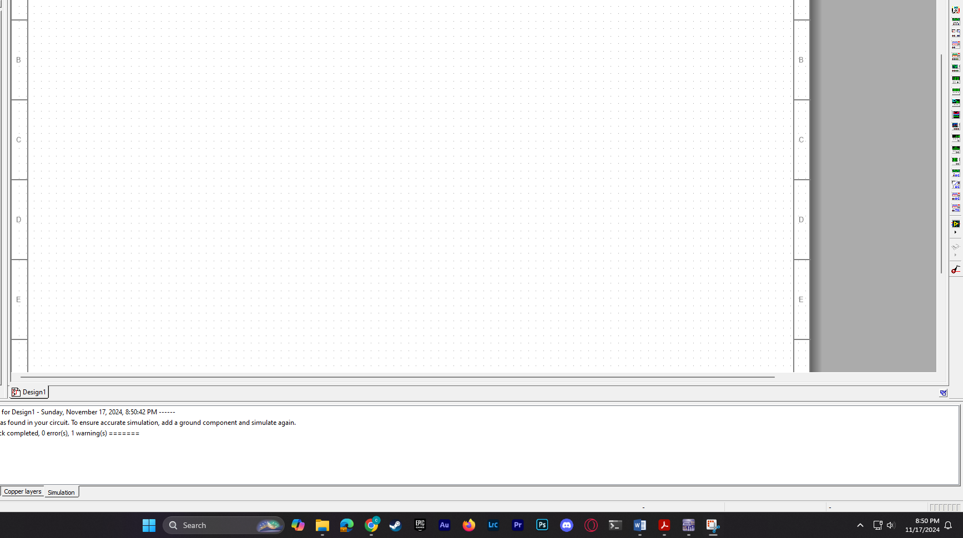










Figure 8: Simulated decoder.

Afterwards, a decimal to BCD encoder was implemented and simulated.

Table 4: Truth table for BCD encoder
Dec. | Y3 | Y2 | Y1 | Y0
D0 | 0 | 0 | 0 | 0
D1 | 0 | 0 | 0 | 1
D2 | 0 | 0 | 1 | 0
D3 | 0 | 0 | 1 | 1
D4 | 0 | 1 | 0 | 0
D5 | 0 | 1 | 0 | 1
D6 | 0 | 1 | 1 | 0
D7 | 0 | 1 | 1 | 1
D8 | 1 | 0 | 0 | 0
D9 | 1 | 0 | 0 | 1

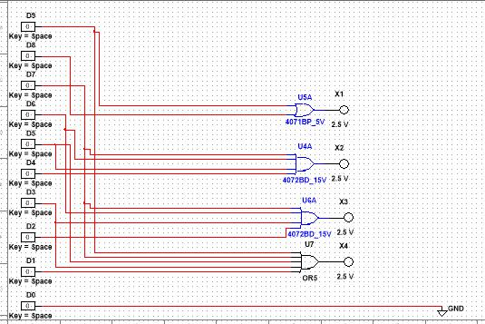
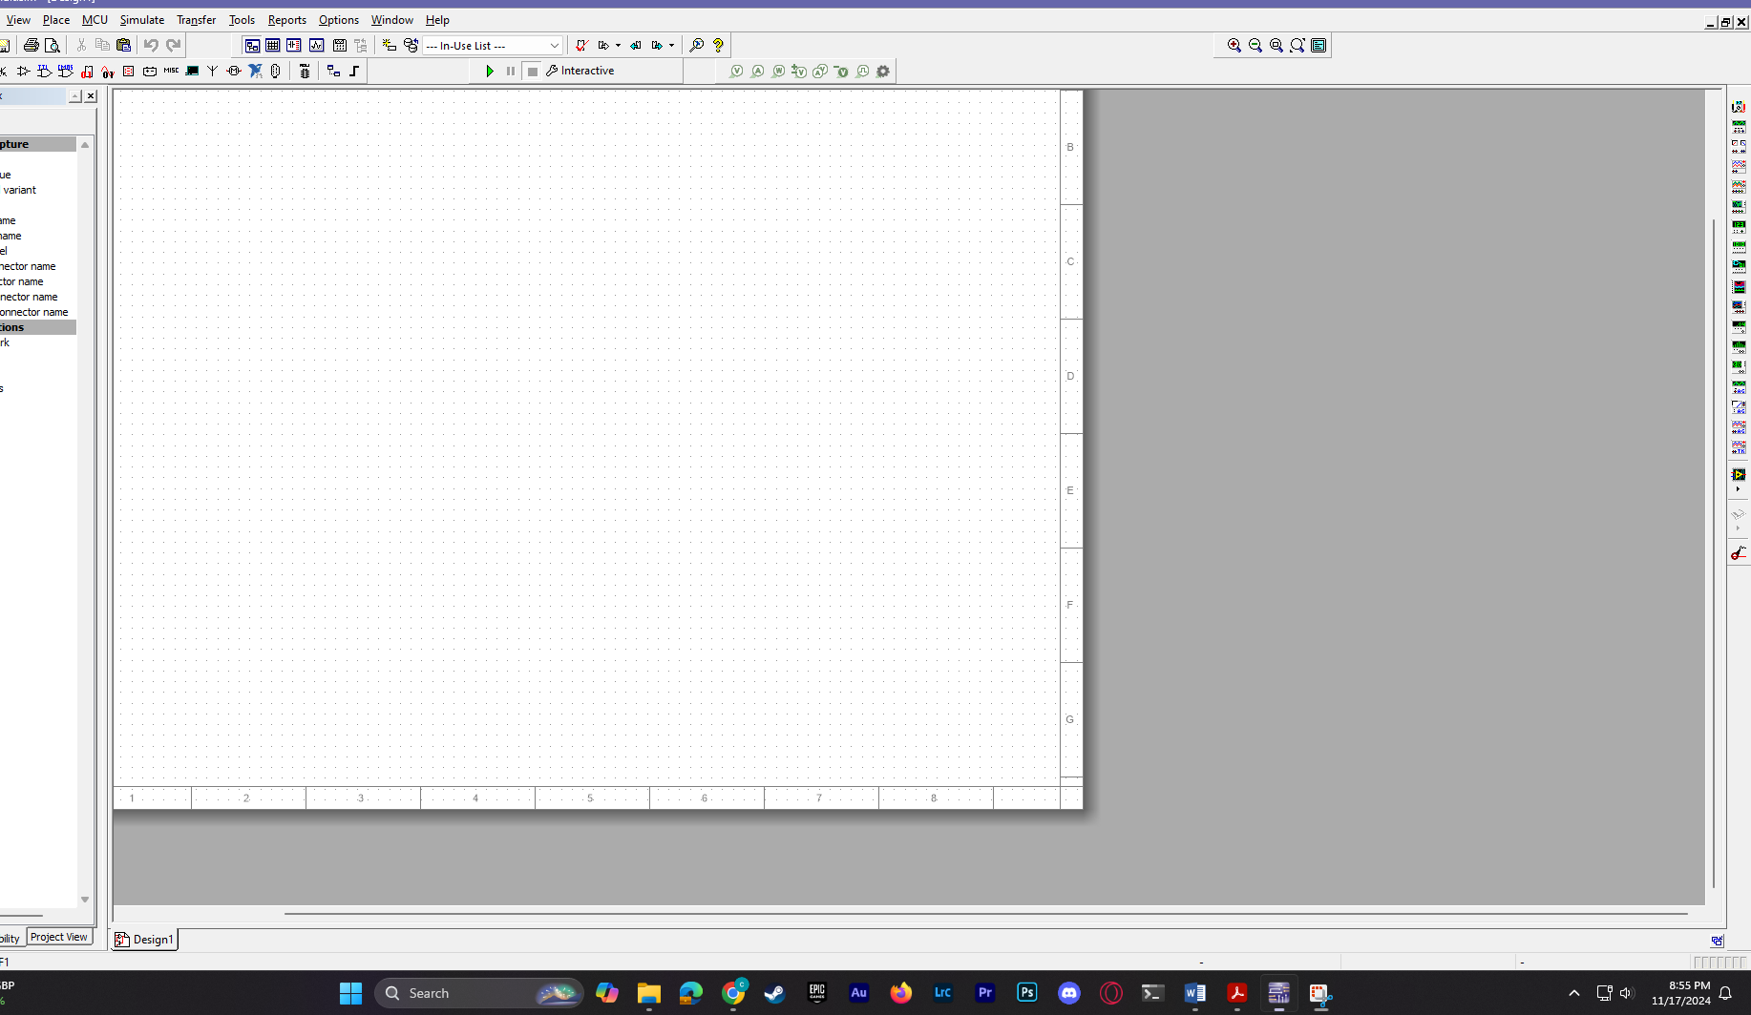

Figure 9: Simulated BCD encoder.

Finally, a 4-to-2 priority encoder was implemented with a priority sequence of 2,1,3,0.

Table 5: Truth table for priority encoder.
A3 | A2 | A1 | A0 | Y1 | Y0
X | 1 | X | X | 1 | 0
X | 0 | 1 | X | 0 | 1
1 | 0 | 0 | X | 1 | 1
0 | 0 | 0 | 1 | 0 | 0



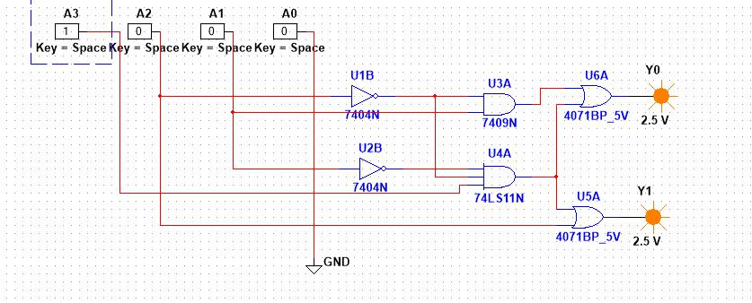

Figure 10: Priority encoder.

Hardware Implementation:

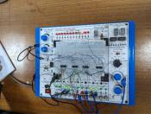
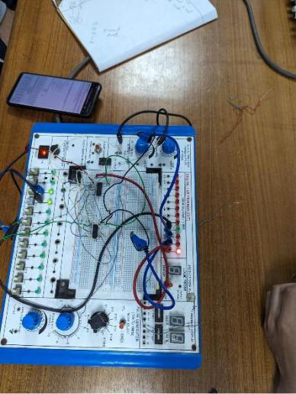

figure-2: Mux

figure-1:2_to_4 line decoder
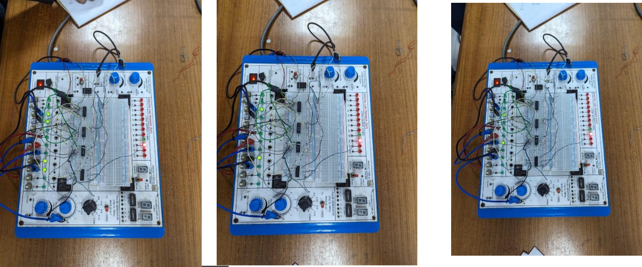

figure-3: Decimal to BCD encoder

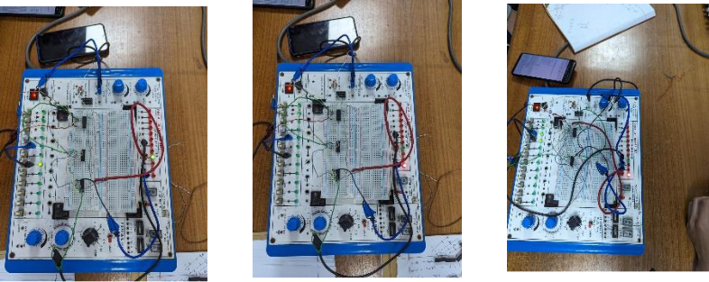

figure-4: De-Mux

Results:

1.Only a problem with the priority encoder was discovered despite all the circuits being accurately simulated. The problem has been fixed in the simulation.

2.All the truth tables were generated during the simulation, and no discrepancies were found.

Discussions:

Every circuit shown here was done on Multisim simulation and physically. But some difficulties were faced during BCD encoder and de-mux, and it could not be done perfectly due to time shortage and skill issue. But it was solved with the help of Multisim. Also priority encoder wasn’t done physically

References:

- http://www.tutorialspoint.com/computer_logical_organization/combinational_circuits.ht m

